**Bing API Documentation for Touching Data**

1. Go to <https://azure.microsoft.com/en-us/free/services/cognitive-services/> and click the “Start Free” button.

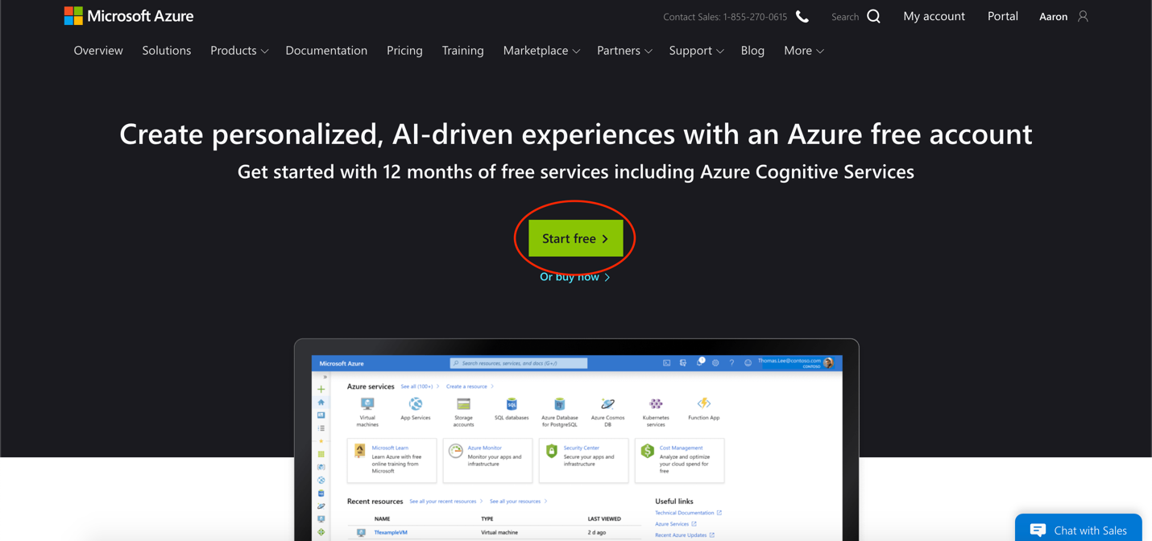

1. Either log in using an existing Microsoft account or create a new account.

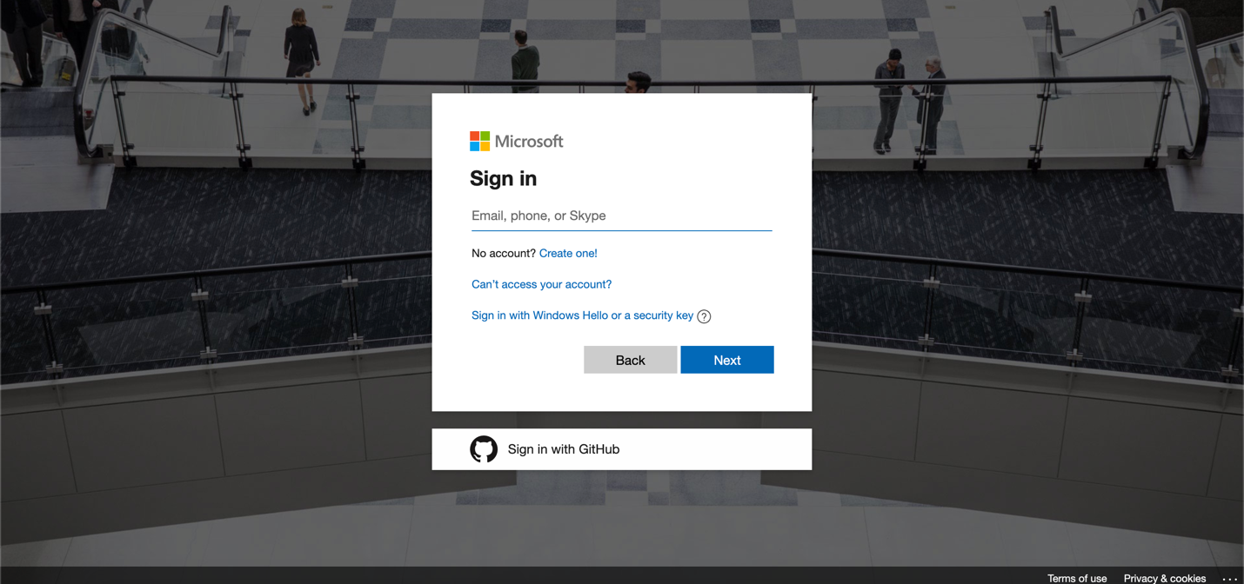

1. After either creating a new account or logging into an existing one. Go the developer portal.

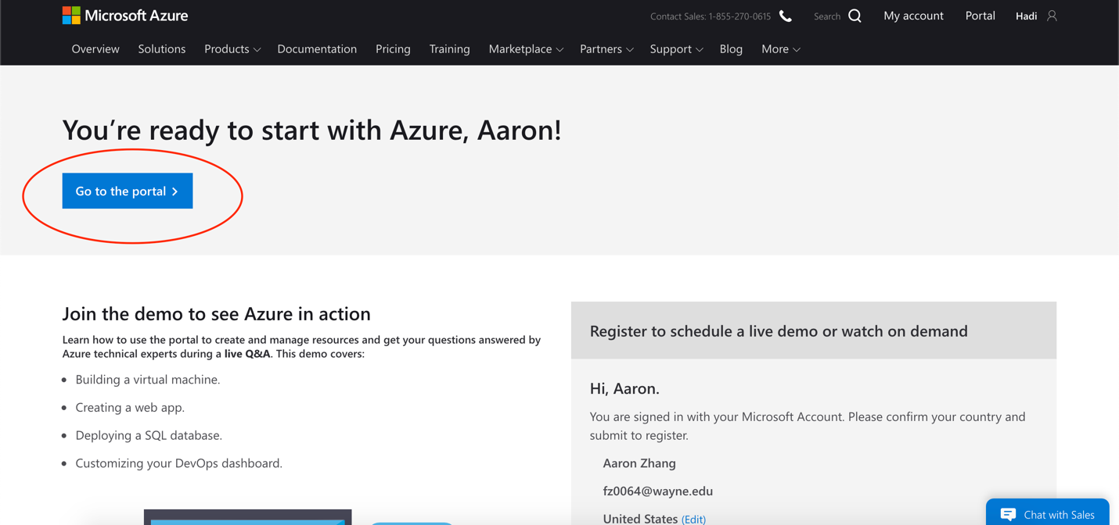

1. On the search bar, enter the term “**Bing Search**” and click on **Bing Search** result under the **Marketplace** category

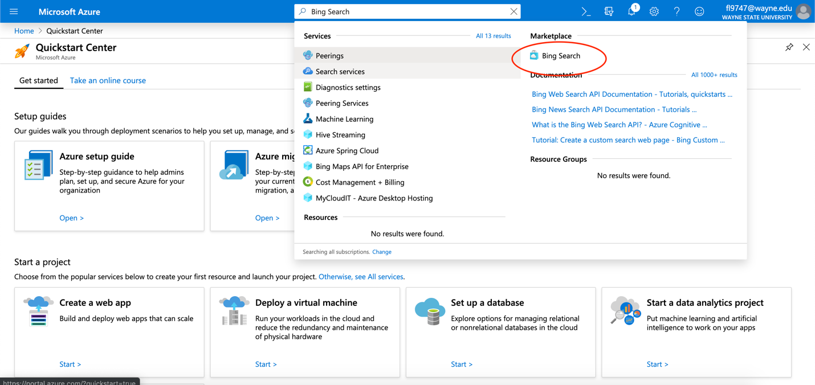

1. The Create Screen will prompt you to enter information. It does not matter what your **Application Name** or **Resource Group** is. But make sure your **Subscription** is under Free Trial and your **Pricing Tier** is F1 as these are the free tiers. Click **Create** when the information is all entered

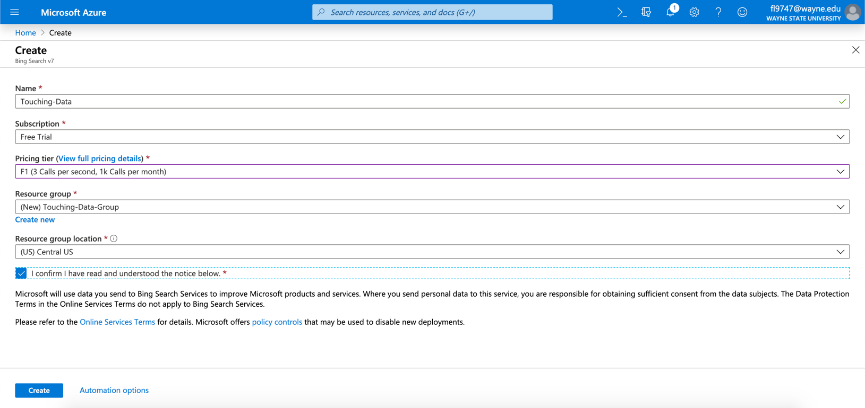

1. You should then be taken to the overview page. Deployment of the API will start, this will take a short amount of time.

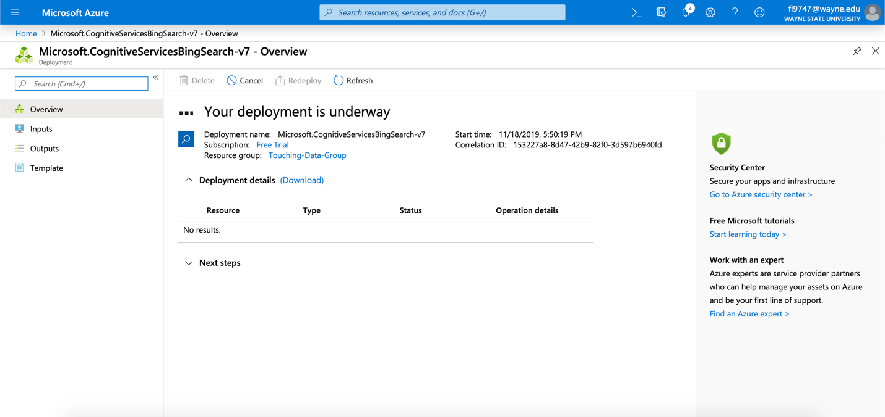

1. After Deployment is done, click on the button which is labelled “Go to resource”

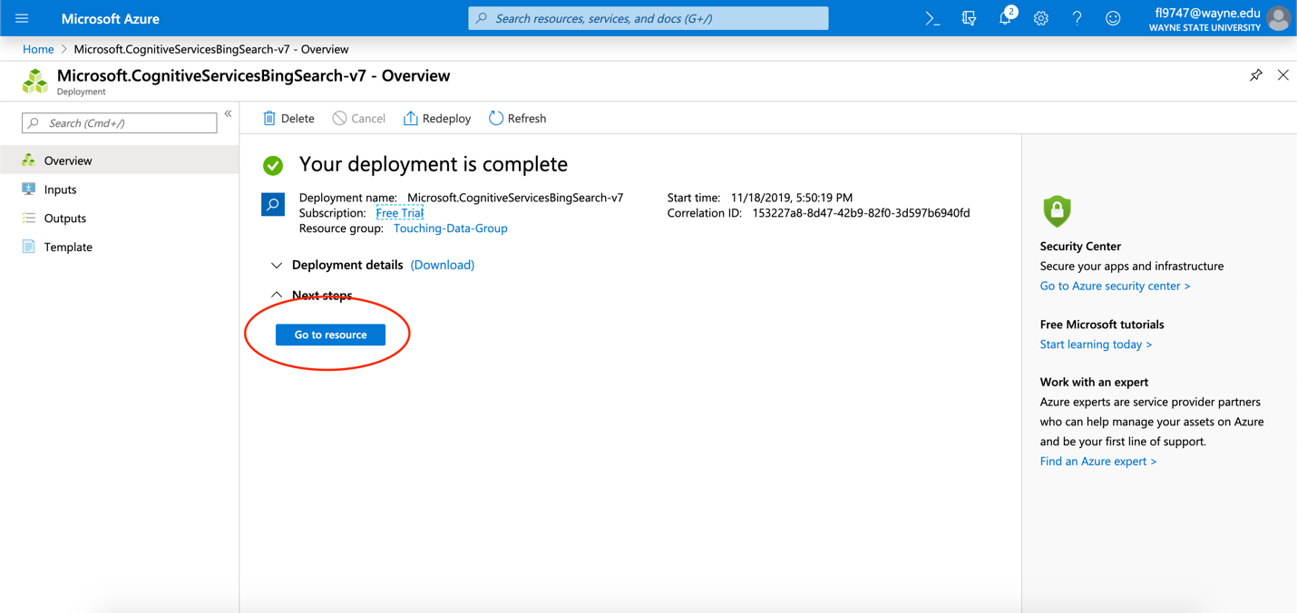

1. You will then be taken to the actual deployment page. From there under **1**, there will be a value called **Key1.** Copy and paste this key and save it for later.

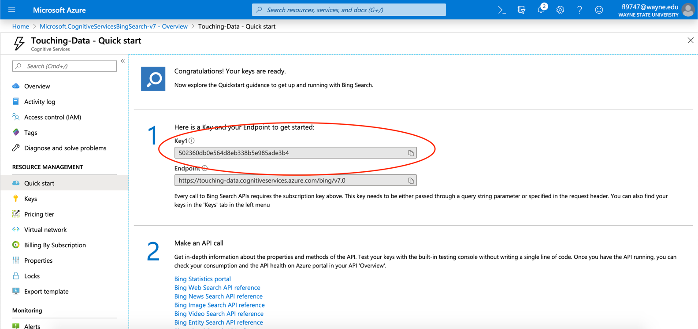

1. Open the text file which is located at app/web-scraping/src/webscraper_controller.js. Change line 17, remove the old key and insert the new one. Save the file and the Bing API should have more searches now.

